**(CSE131) Computer Programming**

**Sophomore CESS**

**FALL 2022**

**Team (26) Major Task**

|  |  |
| --- | --- |
| Name | ID |
| Ahmed Mohamed Mohamed | 22P0283 |
| Ahmed Ehab Mohamed El-Baramony | 21P0261 |
| Ahmed Mohamed Hassan El-Henawy | 21P0298 |
| Omar Ahmed El-Sayed Azab | 19P2907 |
| Omar Hussein Ahmed Ahmed | 2001718 |

1. **Overview:**

The **Crime Investigation Management System** is being used to report all the crimes. Whenever a crime or any unwanted activity is being suspected then the system will record the activity and save it as a reference for further assistance. The system also keeps track of all the criminals from their past to present in order to maintain a good environment and so that in future if the criminal does any crime then the police can use the database which is being already stored in the servers for assisting that criminal activity.

1. **Deliverables:**

**Functions:**

1 – User Login (Username, Password):

a. **Admin**→ The admin is an authorized person with privileges to all the activities which had been recorded into the database or all the motions that had been saved. Not every common person has the right to check all the motions, images and all the activities and data that have been recorded into the system database.

b. **Officer**→ He can check his assigned cases and the criminal records only.

2 – Add New Record

3 – Delete A Record

4 – Display All Records

5 – Update/Modify Any Existing Record

6 – Search For Any Existing Record

7 – Program Continuously Loop Until User Exit The Problem

1. **List Of Figures:**

Figure 1 Admin Login 4

Figure 2 Officer Login 4

Figure 3 Admin Display All Records 5

Figure 4 Officer Display All Records 5

Figure 5 Admin Search for A Record 6

Figure 6 Officer Search for A Record 6

Figure 7 Modify Record 7

Figure 8 Adding A Record 8

Figure 9 Display All After Adding Records 8

Figure 10 Deleting A Record 9

Figure 11 Display All After Deleting ID = 3 9

Figure 12 Final Window & Program Closes 10

1. **How To Use Our Program:**

**1- Login Page**

**Cin >> “1”**

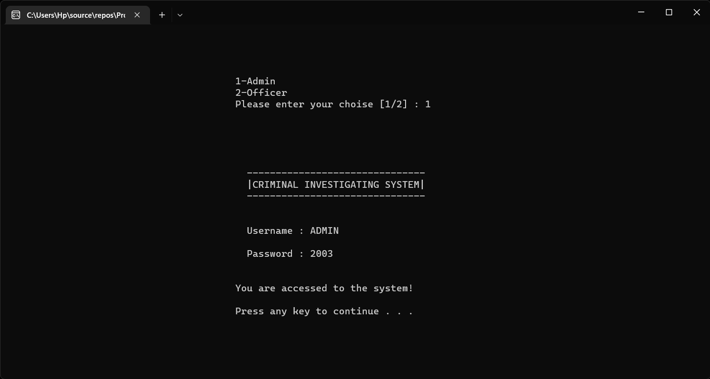

Figure 1 Admin Login

1. Choose whether you are loginng in as an **ADMIN** or **OFFICER** by entering a number [1/2].
2. If you are an **ADMIN** you need to enter a username & password.

**The User Has 3 Tries To Enter Admin Login Info**

If User Happen To Enter The Info More Than Limit The Program Will Exit Automatically!

|  |  |
| --- | --- |
| **Username** | ADMIN |
| **Password** | 2003 |

1. If you are logging in as an **OFFICER** you don’t need to enter a username or a password.

**Cin >> “2”**

Figure 2 Officer Login

**2- Display All Records**

**Cin >> “5”**

Figure 3 Admin Display All Records

1. We hard coded two records:

|  |  |  |  |
| --- | --- | --- | --- |
| **Criminal ID** | **Criminal Name** | **Crime Committed** | **Date** |
| 0 | Mark | Murder | 25/2/2010 |
| 1 | Jack | Kidnap | 12/5/2015 |

1. The output is displayed in a form of a table, we used **cout** function to do so.

**Cin >> “2”**

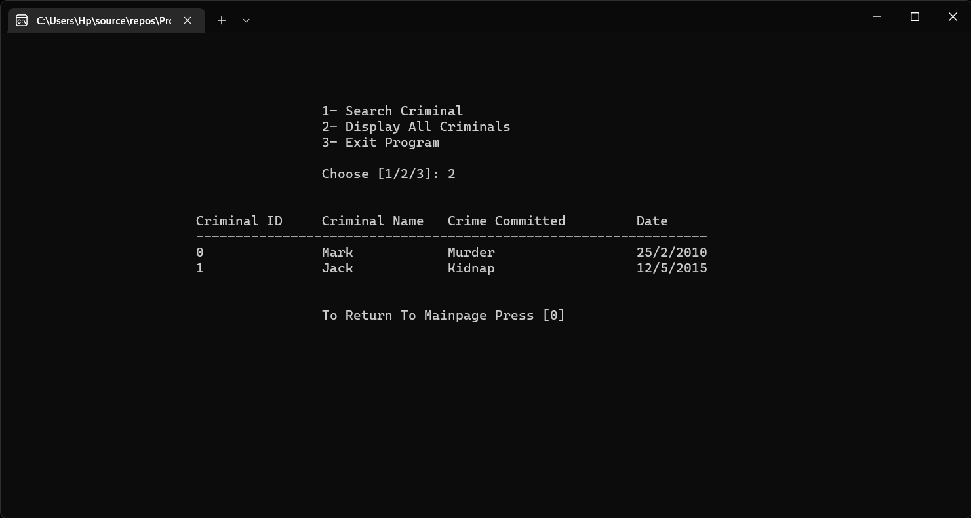

Figure 4 Officer Display All Records

**3- Search Record**

**Cin >> “4”**

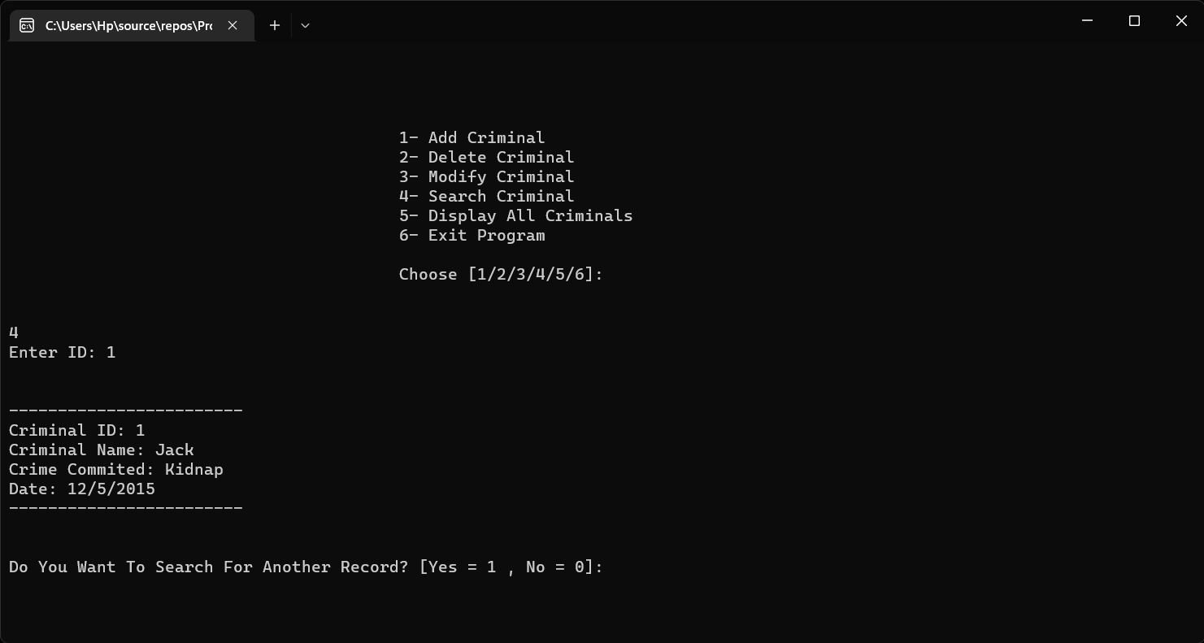

Figure 5 Admin Search for A Record

1. In the search function the user is asked to enter a **Criminal ID** to search for it in the records array
2. The **Criminal ID**, **Criminal name**, **Crime Committed** & **Date** is then displayed.
3. If by any means the ID was not found a message will be displayed **ID NOT FOUND!**

**Cin >> “1”**

Figure 6 Officer Search for A Record

**4- Modify Record**

**Cin >> “3”**

Figure 7 Modify Record

1. In the modify function we ask the user to enter a **Criminal ID** which he wishes to modify.
2. If the Criminal ID was not found a message will appear **ID NOT FOUND!**
3. If Criminal ID was found the user is given 3 choices:
   1. Modify Name
   2. Modify Crime
   3. Modify Date
4. After entering the modification and pressing enter the user will be asked if he wished to do another modification for the SAME **Criminal ID.**
5. If user wishes to make another modification for a **different Criminal ID**, he must exit the Modify option and enter it again to change Criminal ID desired.

**6- Add Record**

**Cin >> “1”**

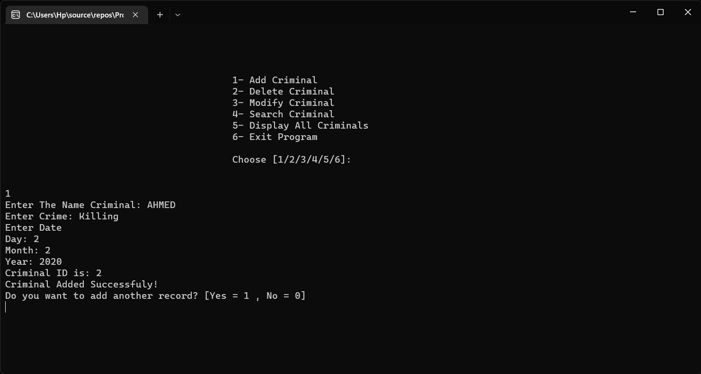

Figure 8 Adding A Record

1. In the Add Record function the user is asked to enter inforamtion about:
   1. Criminal Name
   2. Crime Committed
   3. Date (D – M – Y)
2. The program provide the user with a Criminal ID, so we can avoid 2 problems:
   1. The User from entering the same Criminal ID another time.
   2. Not scrambling the array when deleting.

**The following screenshot for display all function after adding some records**

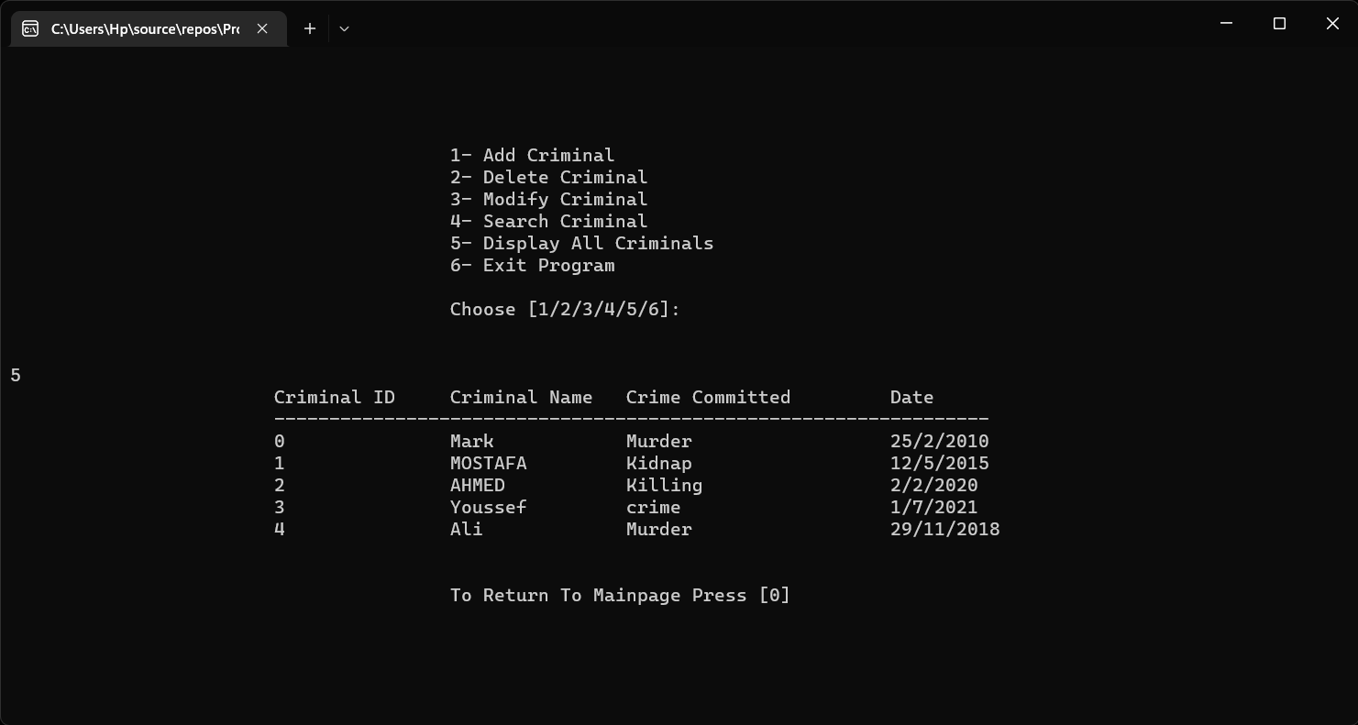

Figure 9 Display All After Adding Records

**6- Delete Record**

**Cin >> “2”**

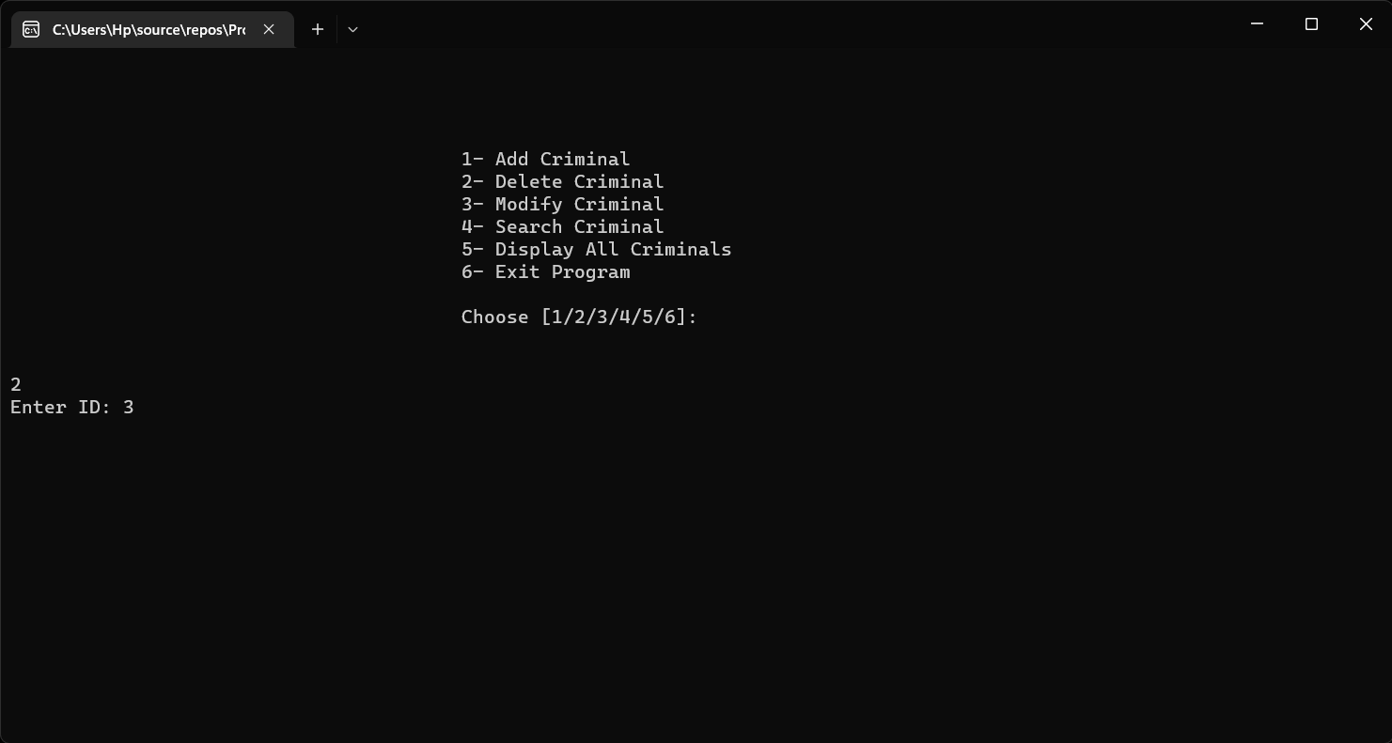

Figure 10 Deleting A Record

1. In the Delete Record function the user is asked to enter **Criminal ID** to be deleted.

**The following screenshot for display all function after deleting a record**

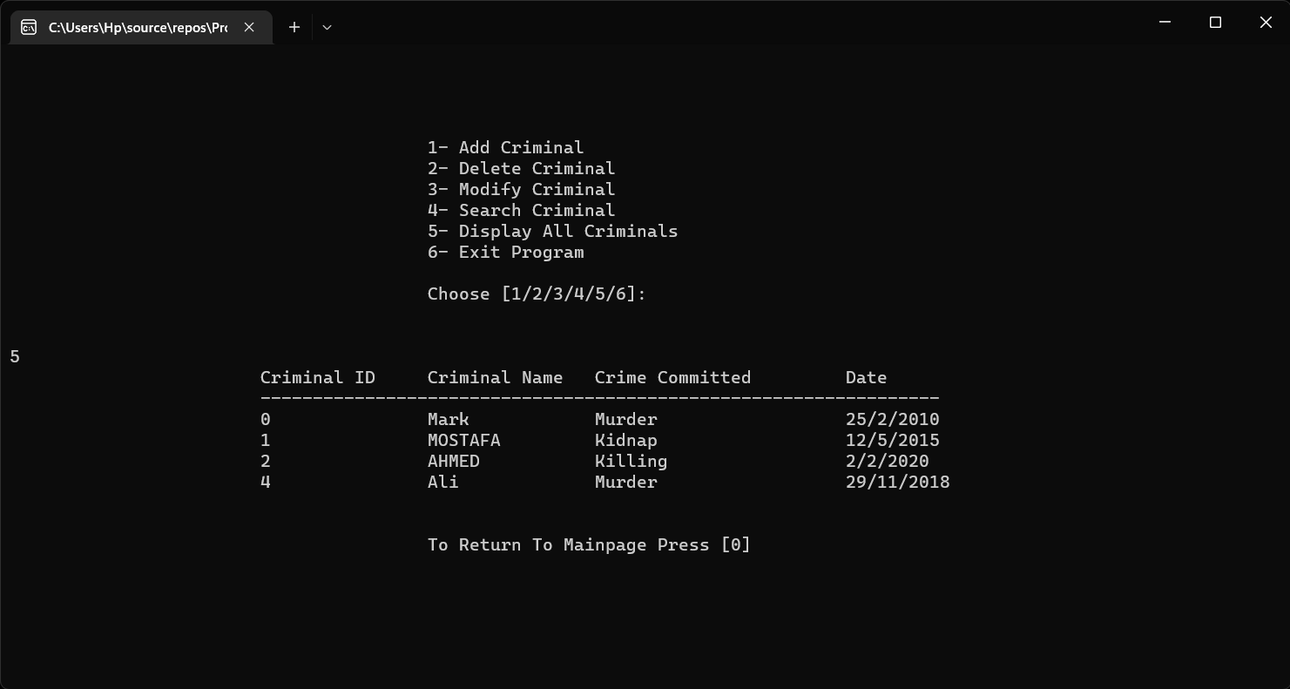

Figure 11 Display All After Deleting ID = 3

**7- Program Looping**

1. After each Function/Option the program **automatically returns to the same menu page** until user chooses to Exit Program

**8- Exiting Program**

**Cin >> “6”**

1. If user enters option 6 the program will redirect user to the final window before exiting the program completely. (**Shown In the Screenshot Below**).

Figure 12 Final Window & Program Closes